**LECTURE 3**

**SOLVING PROBLEMS BY SEARCHING**

Four general steps in problem solving:

1)Goal Formulation:

What are the successful world states?

2)Problem Formulation:

What actions and states to consider given the goal?

3)Search:

Examine different possible sequences of actions that lead to states of known value and then choose the best sequence

4)Execute:

Perform the actions on the basis of the solution.

**PROBLEM SOLVING AGENTS**

A type of goal-based agent - Decide what to do by finding sequences of actions that lead to desirable states.

**PROBLEM SOLVING PROCESS**

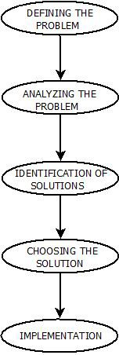

**PROBLEM SOLVING**

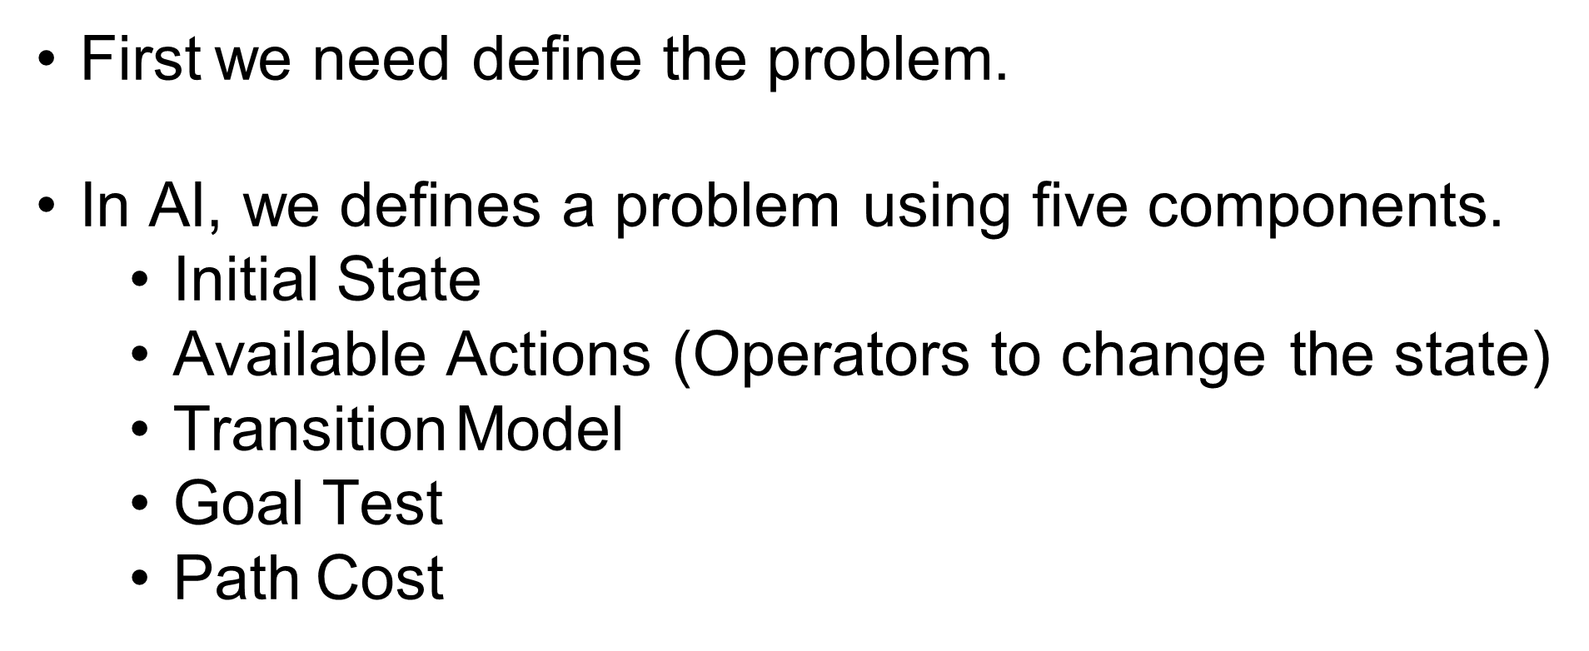

**STATE**

A configuration of the environment and its state.

* A **state** is representation of elements in a given moment.

**STATE SPACE**

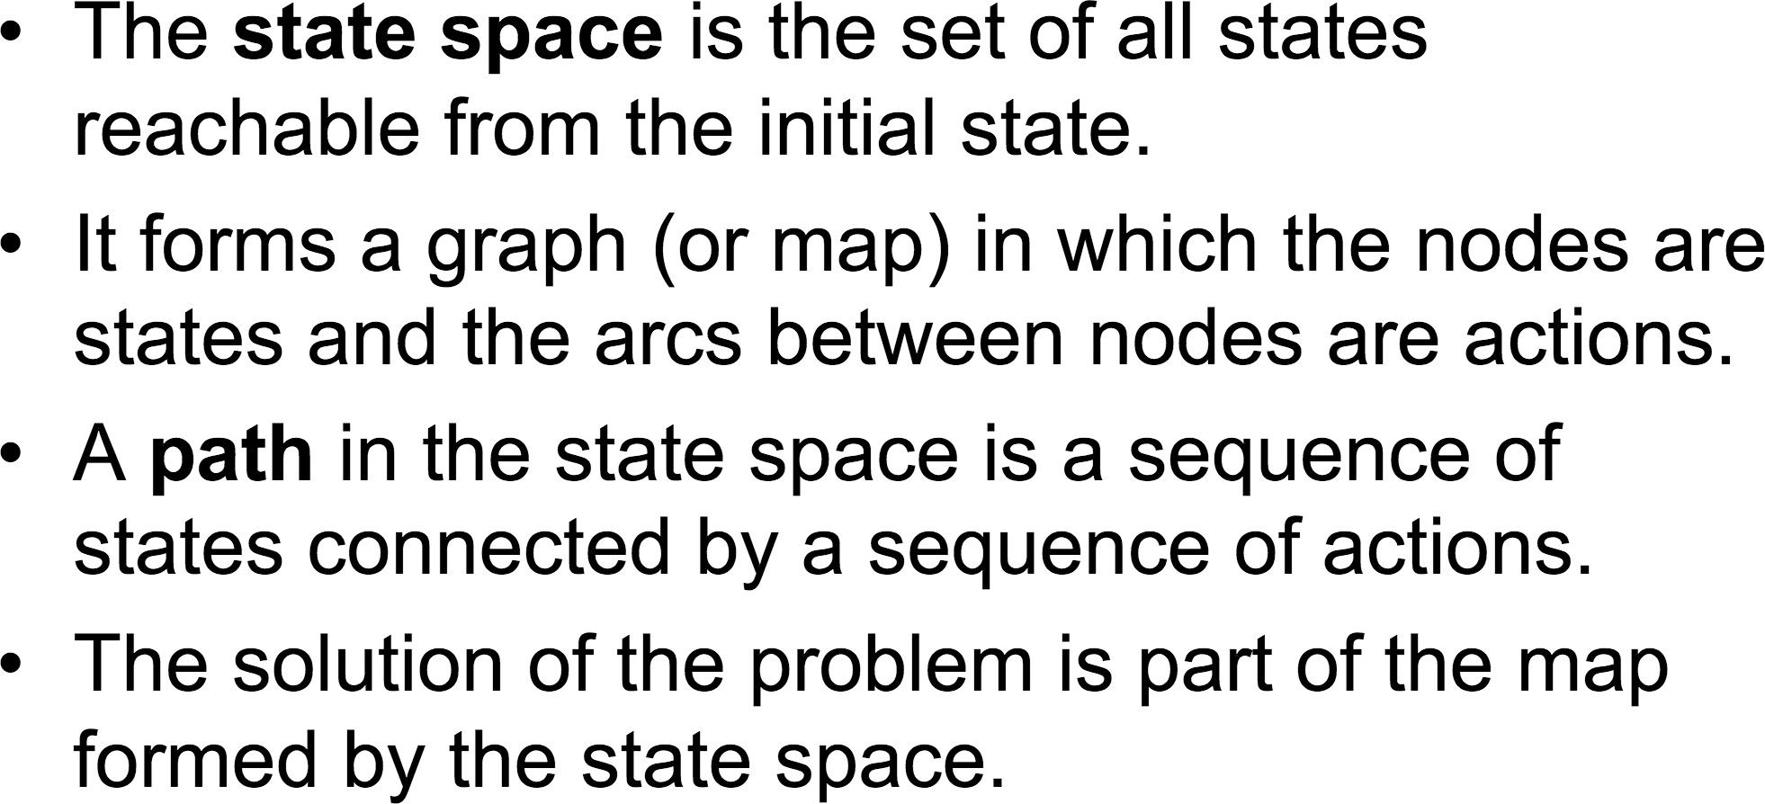

**INITIAL STATE**

Initial state is the state in which the agent begins. The starting point for the searching algorithm. We begin with the initial state and then start to reason about it, to think about the actions we can apply to that initial state in order to figure out how to get from the beginning to the end, from the initial position to whatever the goal it maybe. And how do we make our way from the initial position to the goal.

**GOAL STATE**

Final state of the problem.

**PROBLEM SOLUTION**

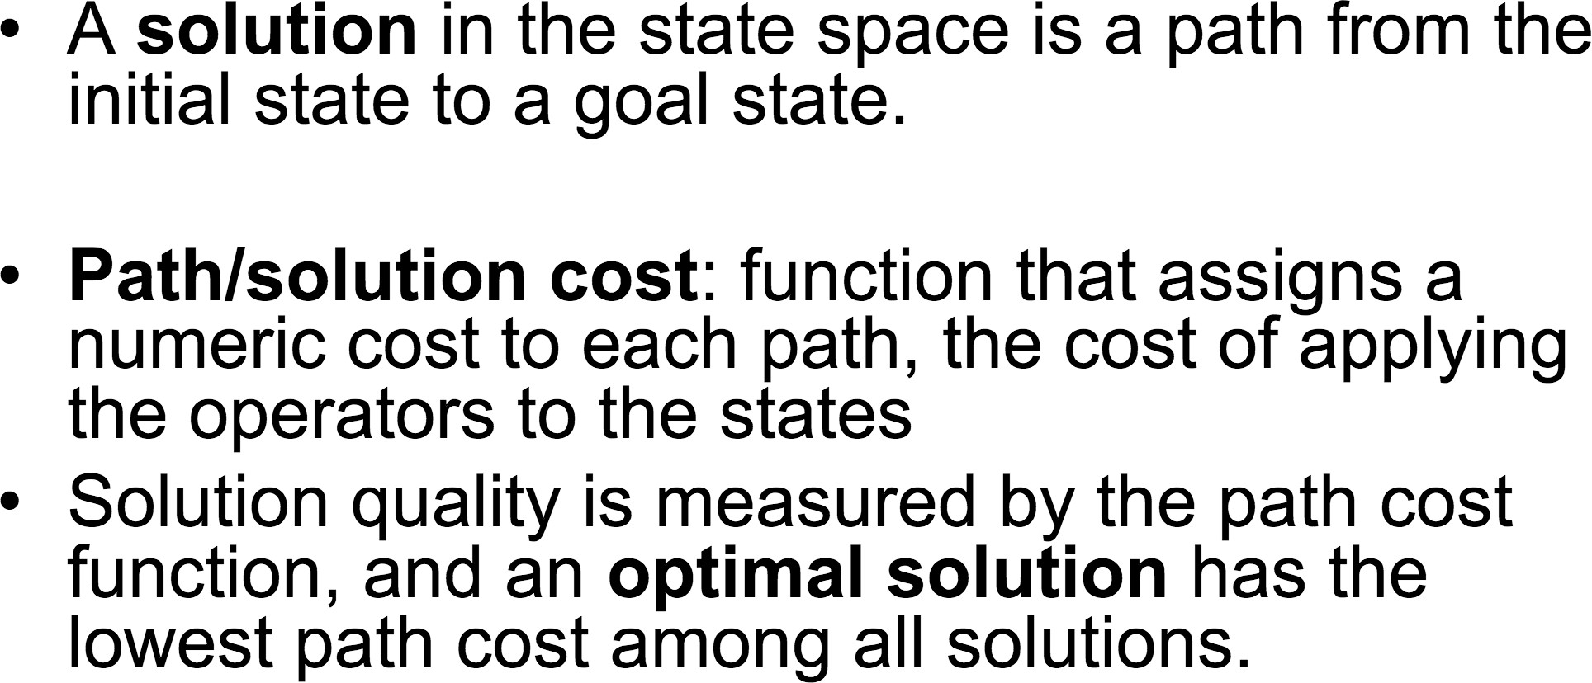

**ACTIONS**

Choices that can be made in a state.

Returns the state of actions that can be executed in states, and actions of s is going to take the state as input and return as output the set of all actions that can be executed in that steatite is possible that some actions are only valid in certain states and not in other states.

**PROBLEM SOLVING BY SEARCHING**

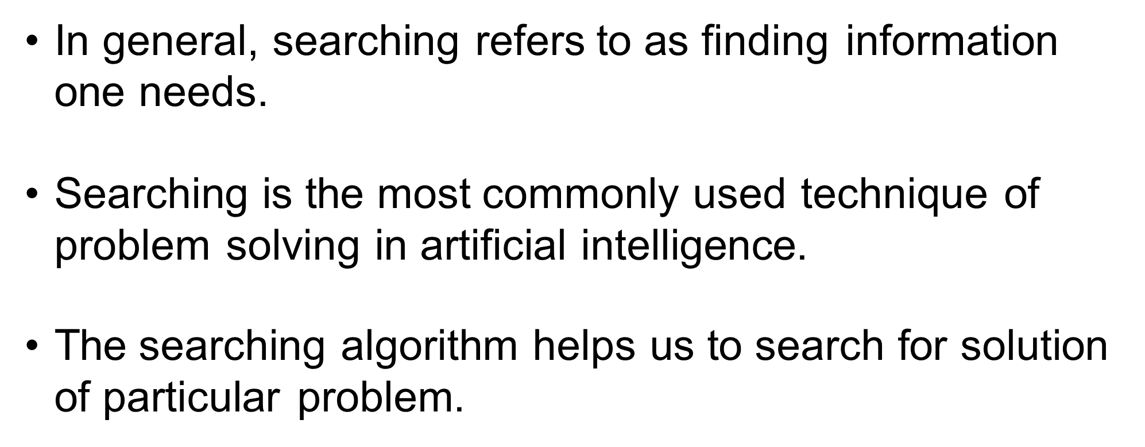

**PROBLEMS OF A SEARCHING ALGORITHM**

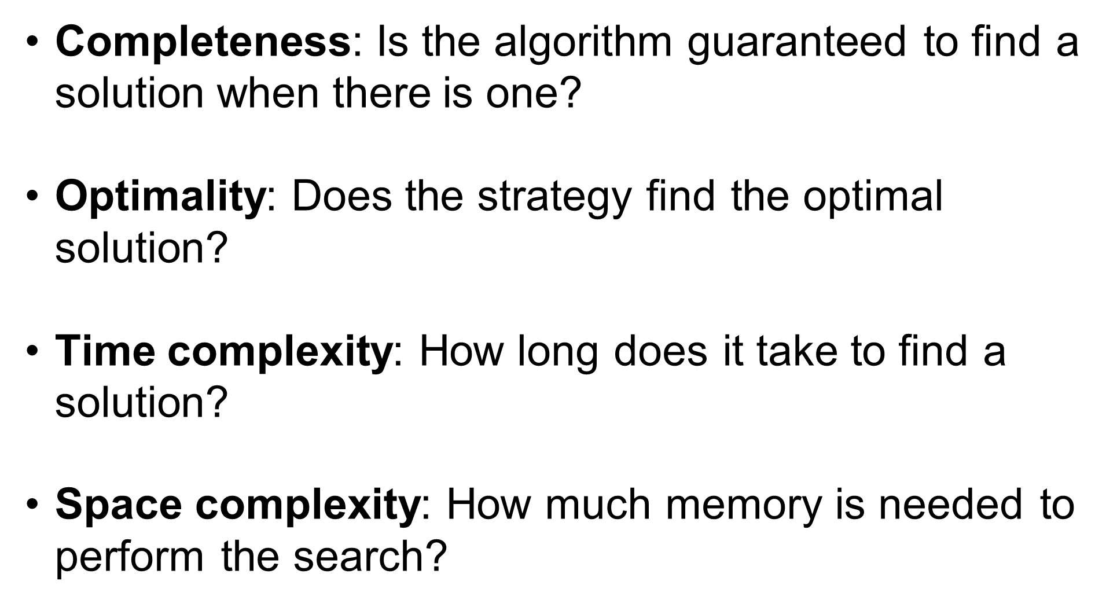

**TYPES OF SEARCH**

1. Uniformed Search(Blind search)
2. Informed Search(Heuristic search)

**TYPES OF UNINFORMED SEARCH**

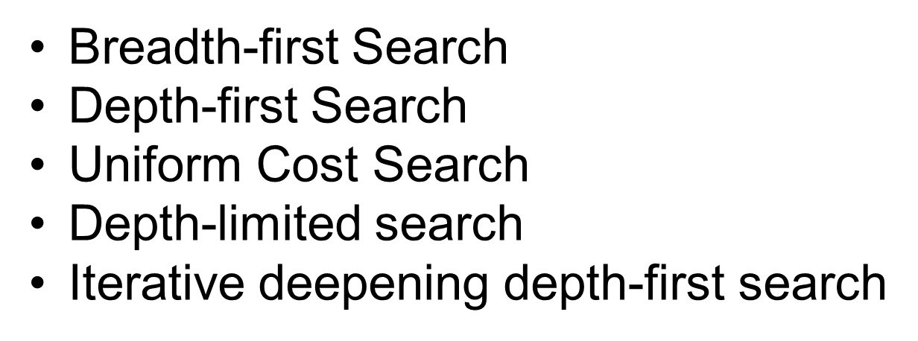

**BREADTH FIRST SEARCH**

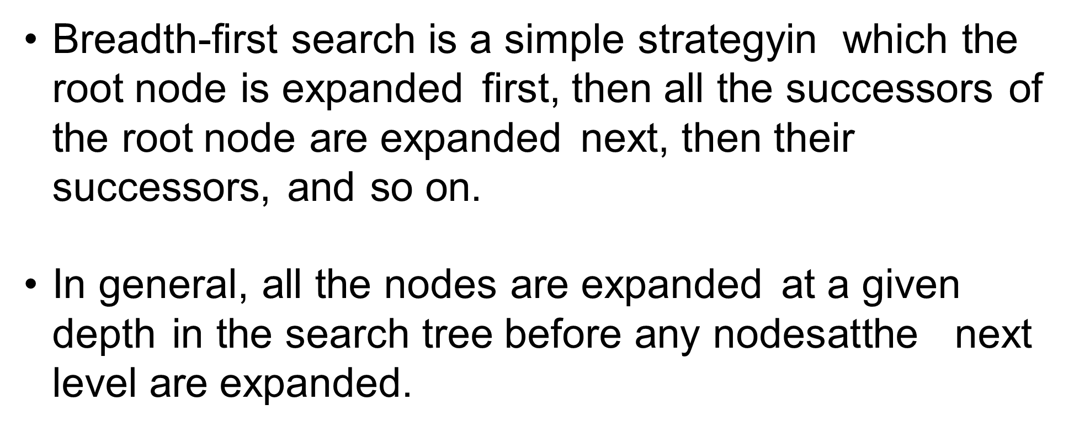

* It Is the most common search strategy to traversing a tree or graph.
* This algorithm searches breadth-wise this is why It is called breadth first search.
* Breadth first search starts searching from the root node and expands all success nodes at the current level before moving to the node of the next level.
* It is implemented using FIFO queue data structure.

**ADVANTAGES**

It will provide a solution if any solution exists.

If there is more than one solution for a given problem, the BFS will provide a minimal solution which requires the least number of steps.

**DISADVANTAGES**

It requires lot of memory since each level of the tree must be saved into memory to expand to next level.

BFS needs a lot of time is far away from the root node.

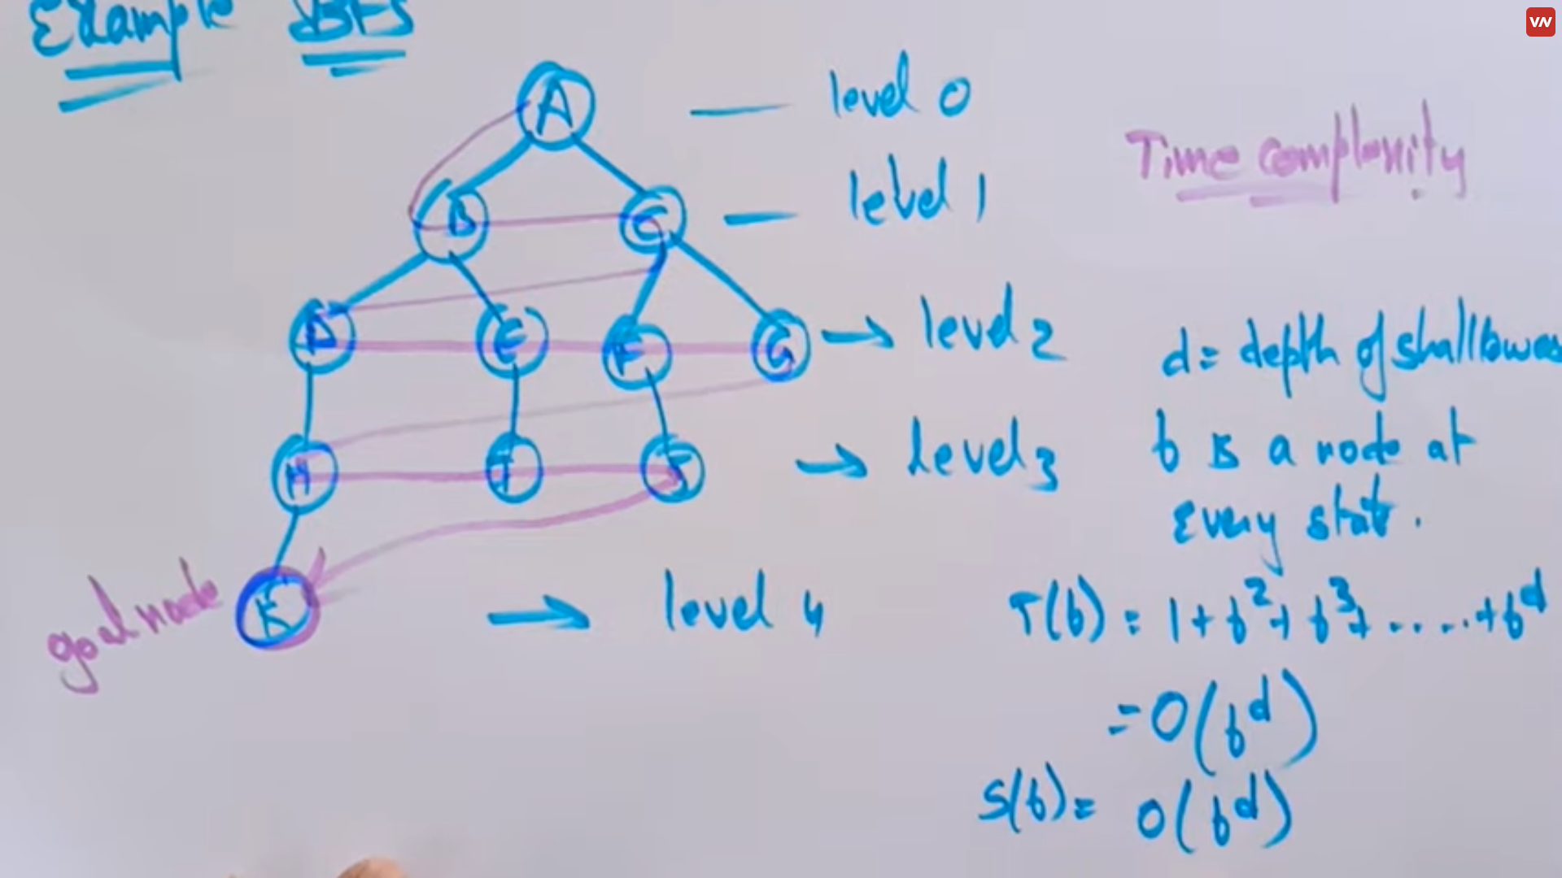

**A – B – C – D – E – F – G – H – I – J – K**

**DEPTH FIRST SEARCH**

It is a recursive algorithm to traverse a tree or a graph data structure.

It is called depth first as it starts from the root node and follows each path to the greatest depth node before moving to the next step.

DFS uses a stack data structure for its implementation, the process is similar to BFS algorithm.

**ADVANTAGES**

Requires less memory as it needs to store only a stack of nodes on the path from the root node to the current node.

It takes less time to reach the goal node than the BFS algorithm.

**DISADVANTAGES**

There is a possibility that many states keep re-occurring and no guarantee of finding the solution.

DFS algorithm goes in deep down searching and sometimes it may go to the infinite loop.

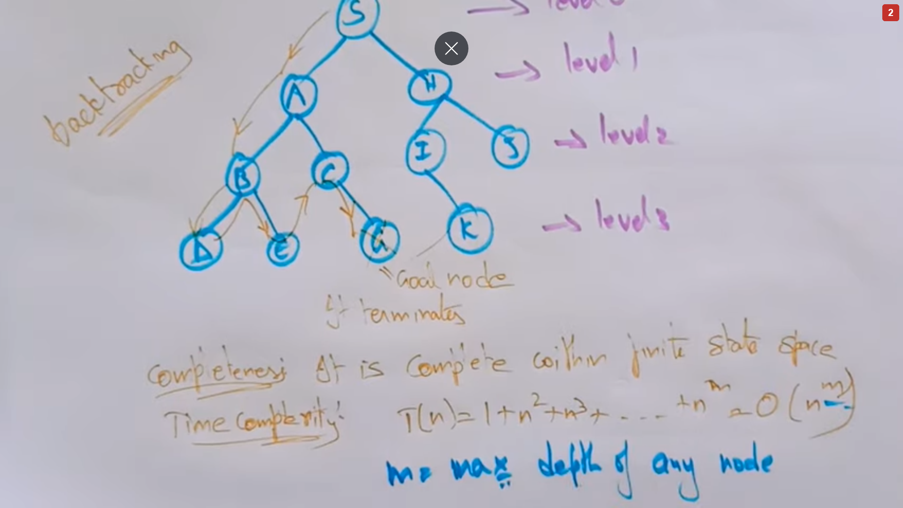

**S – A – B – D – E – C – G – H – I – K – J**

1. First, create a stack with the total number of vertices in the graph.
2. Now, choose any vertex as the starting point of traversal, and push that vertex into the stack.
3. After that, push a non-visited vertex (adjacent to the vertex on the top of the stack) to the top of the stack.
4. Now, repeat steps 3 and 4 until no vertices are left to visit from the vertex on the stack's top.
5. If no vertex is left, go back and pop a vertex from the stack.
6. Repeat steps 2, 3, and 4 until the stack is empty.

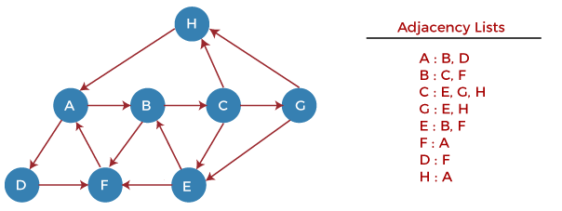

**Step 1** - First, push H onto the stack.

1. STACK: H

**Step 2** - POP the top element from the stack, i.e., H, and print it. Now, PUSH all the neighbors of H onto the stack that are in ready state.

1. Print: H]STACK: A

**Step 3** - POP the top element from the stack, i.e., A, and print it. Now, PUSH all the neighbors of A onto the stack that are in ready state.

1. Print: A
2. STACK: B, D

**Step 4** - POP the top element from the stack, i.e., D, and print it. Now, PUSH all the neighbors of D onto the stack that are in ready state.

1. Print: D
2. STACK: B, F

**Step 5** - POP the top element from the stack, i.e., F, and print it. Now, PUSH all the neighbors of F onto the stack that are in ready state.

1. Print: F
2. STACK: B

**Step 6** - POP the top element from the stack, i.e., B, and print it. Now, PUSH all the neighbors of B onto the stack that are in ready state.

1. Print: B
2. STACK: C

**Step 7** - POP the top element from the stack, i.e., C, and print it. Now, PUSH all the neighbors of C onto the stack that are in ready state.

1. Print: C
2. STACK: E, G

**Step 8** - POP the top element from the stack, i.e., G and PUSH all the neighbors of G onto the stack that are in ready state.

1. Print: G
2. STACK: E

**Step 9** - POP the top element from the stack, i.e., E and PUSH all the neighbors of E onto the stack that are in ready state.

1. Print: E
2. STACK:

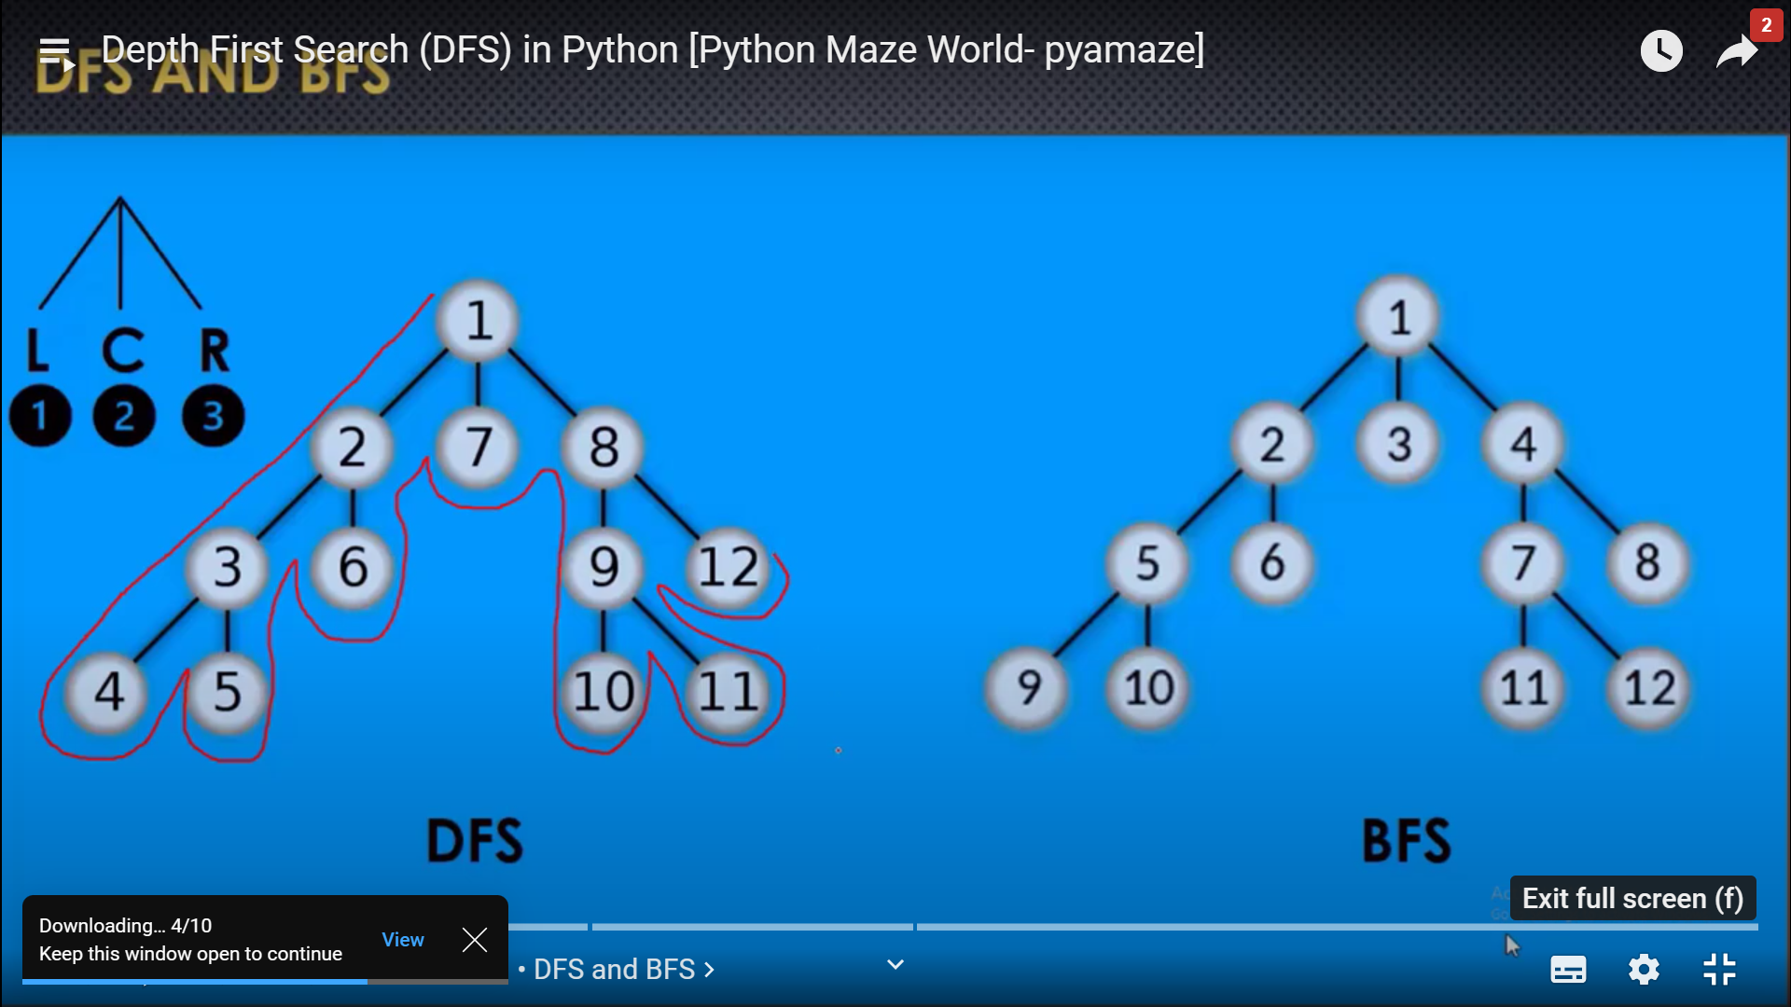

**UNIFROM COST SEARCH**

* It is used to traverse a weighted tree or graph.
* It comes into play when a different cost is available for each edge.
* The goal of UCS is to find a path to the goal node which has the lowest cumulative cost.
* It expands nodes according to their path costs from the root.
* It can be used to solve any graph or tree where the optimal cost is in demand.
* A UCS algorithm is implemented using priority queue.
* It gives priority to the lowest cumulative cost.
* It is equivalent to the BFS If the path cost of all edges is the same.

**ADVANTAGES**

Uniform cost search is optimal because at every state the path with the least cost is chosen.

**DISADVANTAGES**

It does not care the number of steps involved in searching and only cares about the path cost, due to this the algorithm may stuck in an infinite loop.

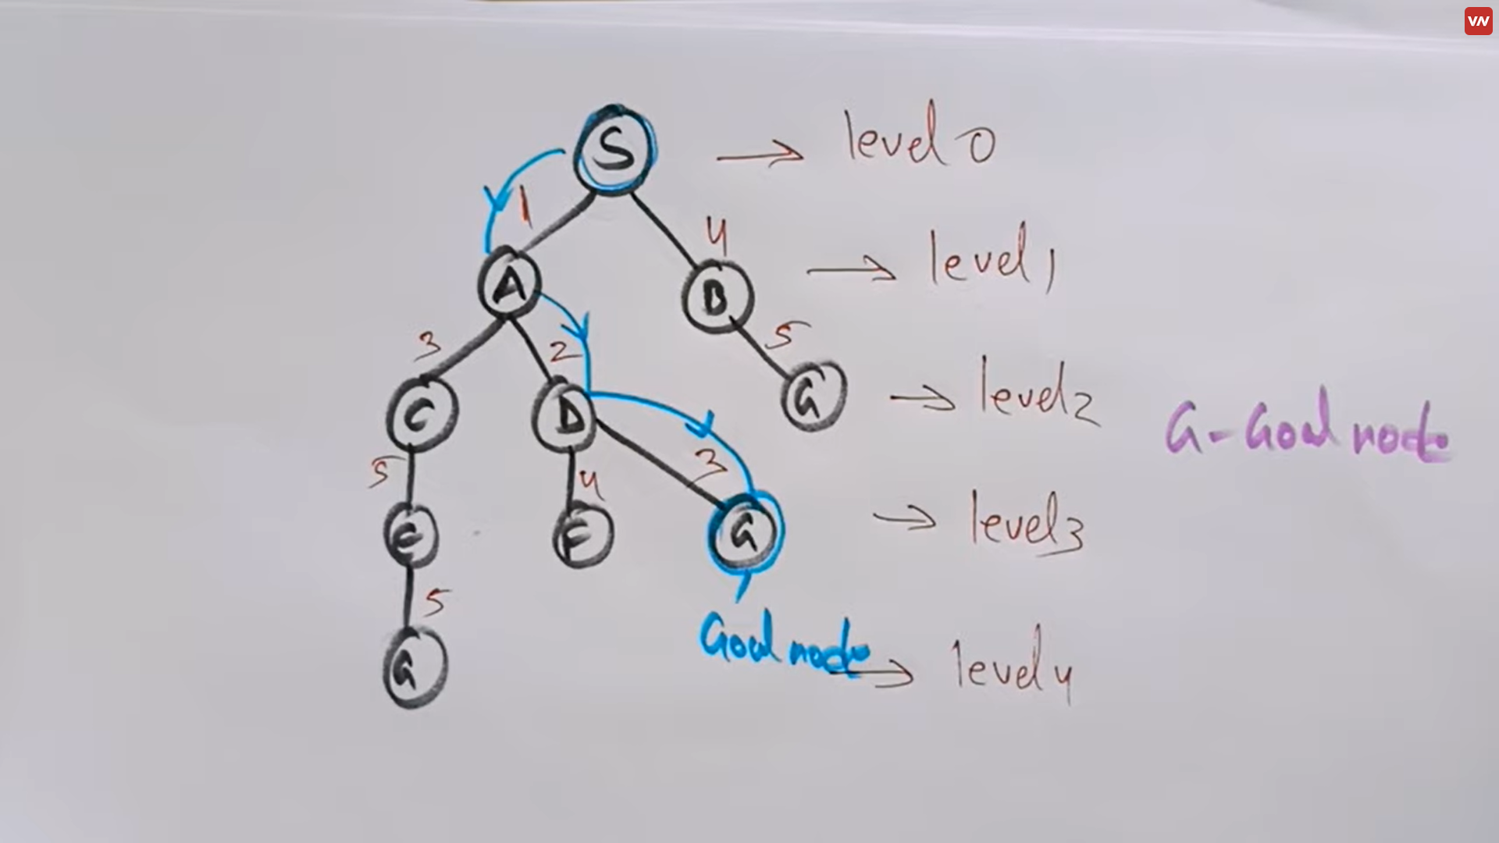

**DEPTH LIMITED SEARCH**

It is similar to DFS with a predetermined limit. DLS can solve the drawback of the infinite path in DFS. On this algorithm the node at the depth limit will treat as it has no success nodes further.

Depth limited search can be terminated with two conditions of failure:

1. Standard failure value: It indicates that problem does not have a solution.
2. Cut-off failure value: It means no solution for the problem withing a given depth limit.

**ADVANTAGES**

It is memory efficient.

**DISADVANTAGES**

Incompleteness

It may not be optimal if the problem has more than one solution.

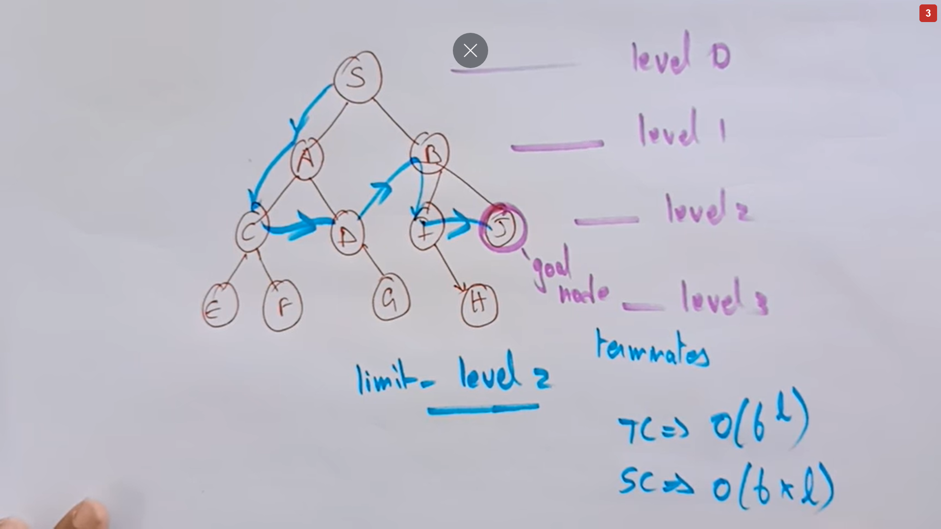

Consider the given graph with Depth Limit(l)=2, Target Node=H and the given source node=A

**Step 1 :**  
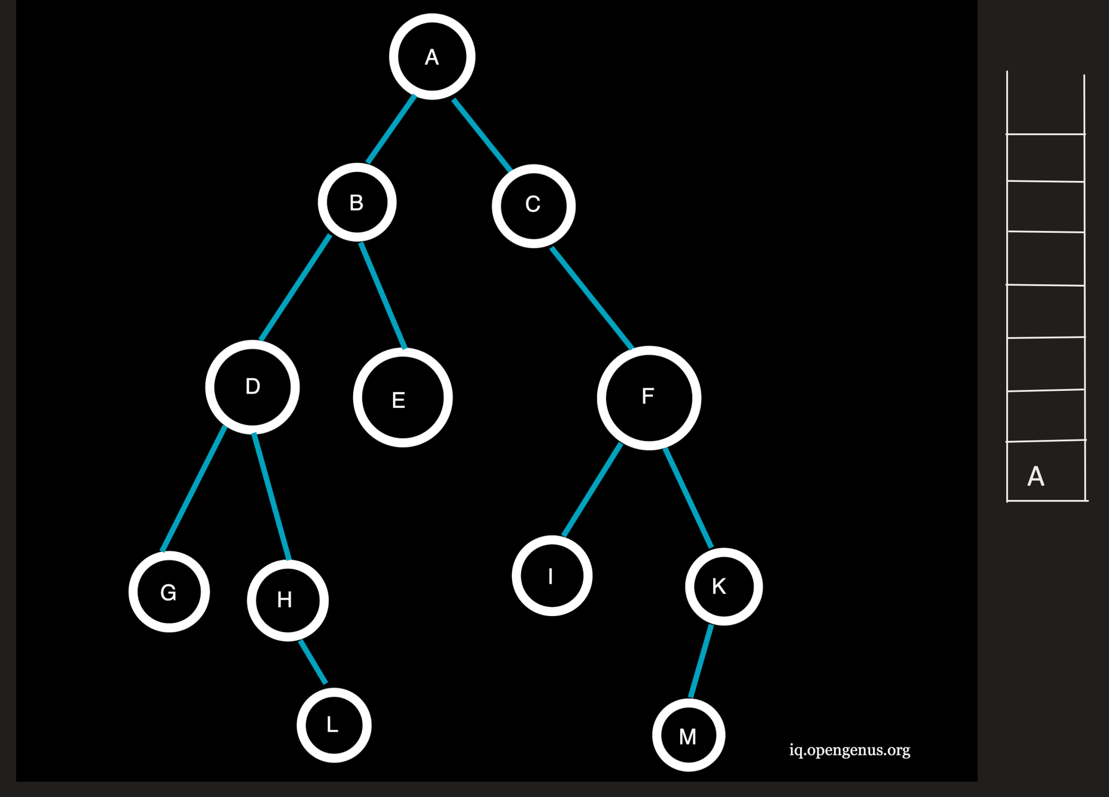

Now, the first element of the source node is pushed onto the stack.

**r :**  
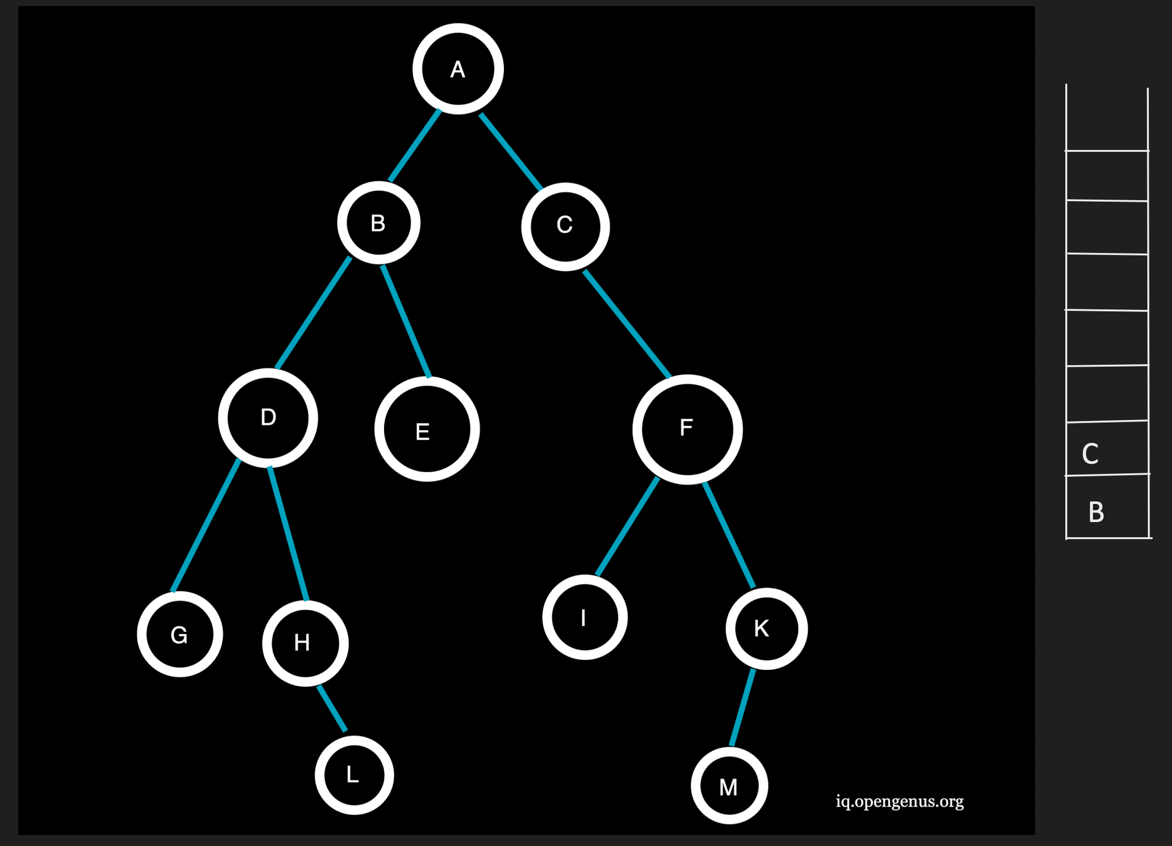

A being the top element is now popped from the stack and the neighboring nodes B and C at depth=1(<l) of A are pushed onto the stack.  
Traversal: A

**Step 3 :**  
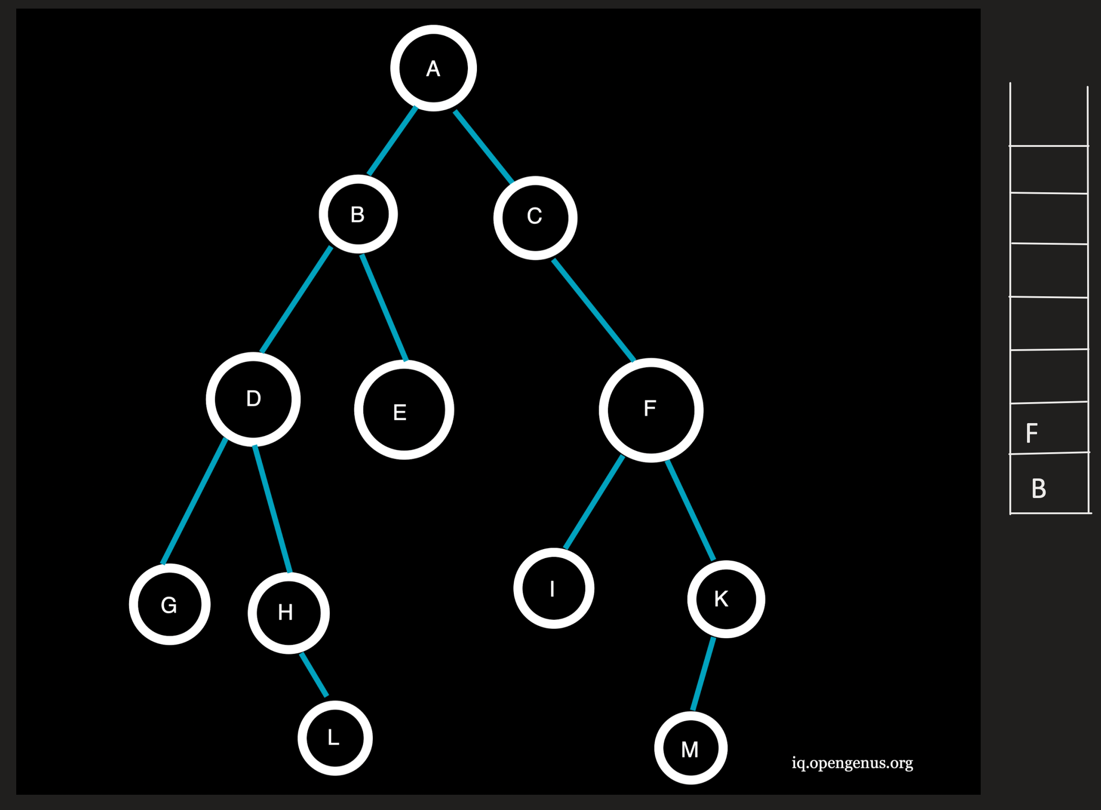

C being the topmost element is popped from the stack and the neighboring node F at depth=2(=l) is pushed onto the stack.  
Traversal: AC

**Step 4 :**  
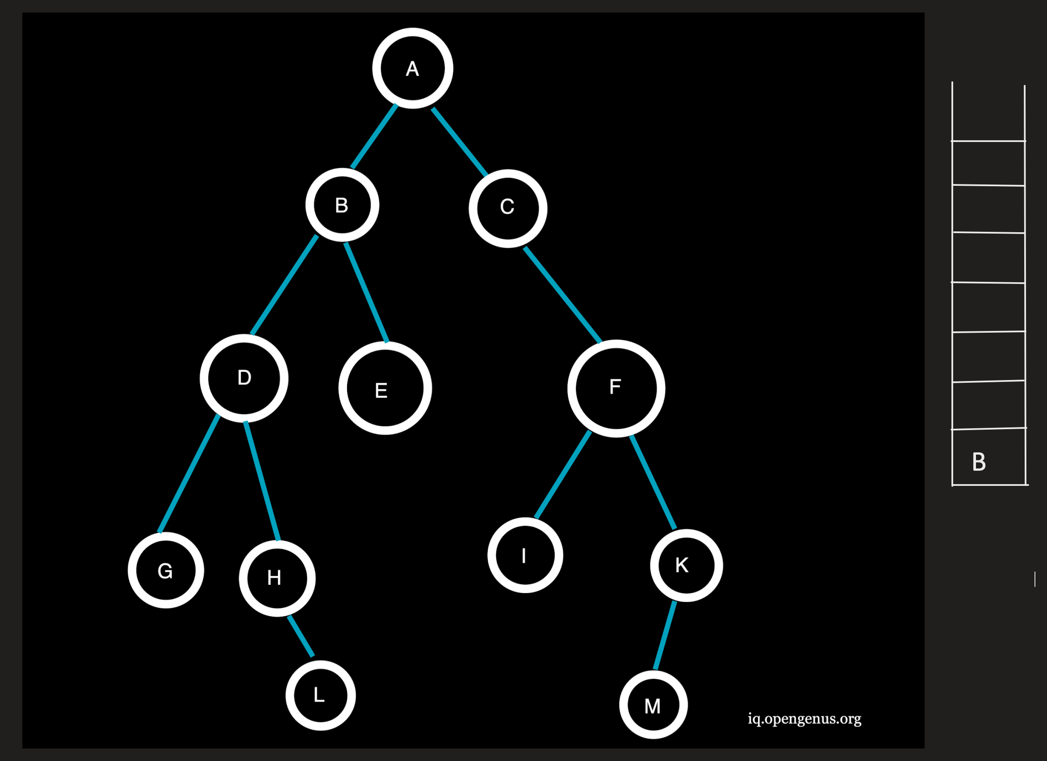

F being the topmost element is popped from the stack and the neighboring nodes I and J at depth=3(>l) will not be pushed onto the stack.  
Traversal: ACF

**Step 5 :**  
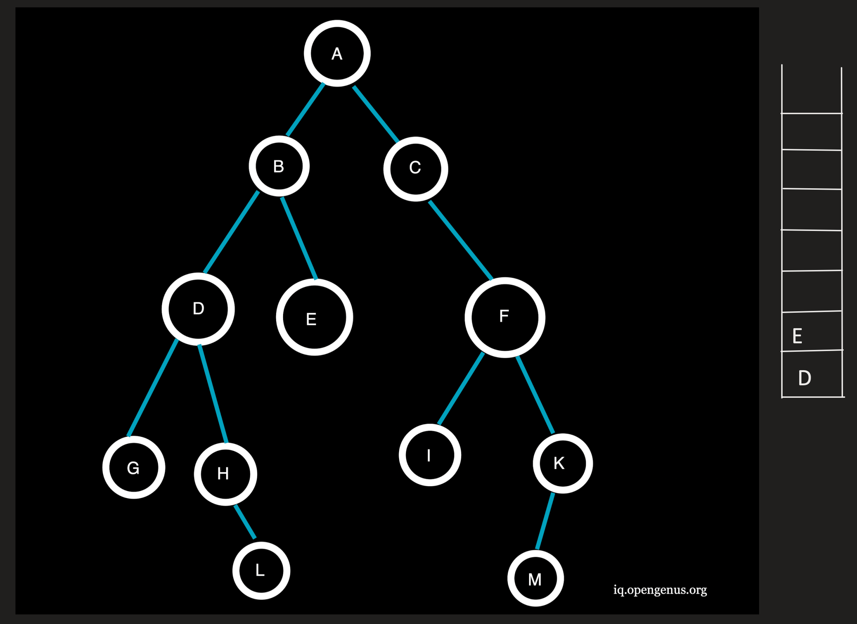

B being the topmost element is popped from the stack and the neighboring nodes D and E at depth=2(=l) are pushed onto the stack.  
Traversal: ACFB

**Step 6 :**  
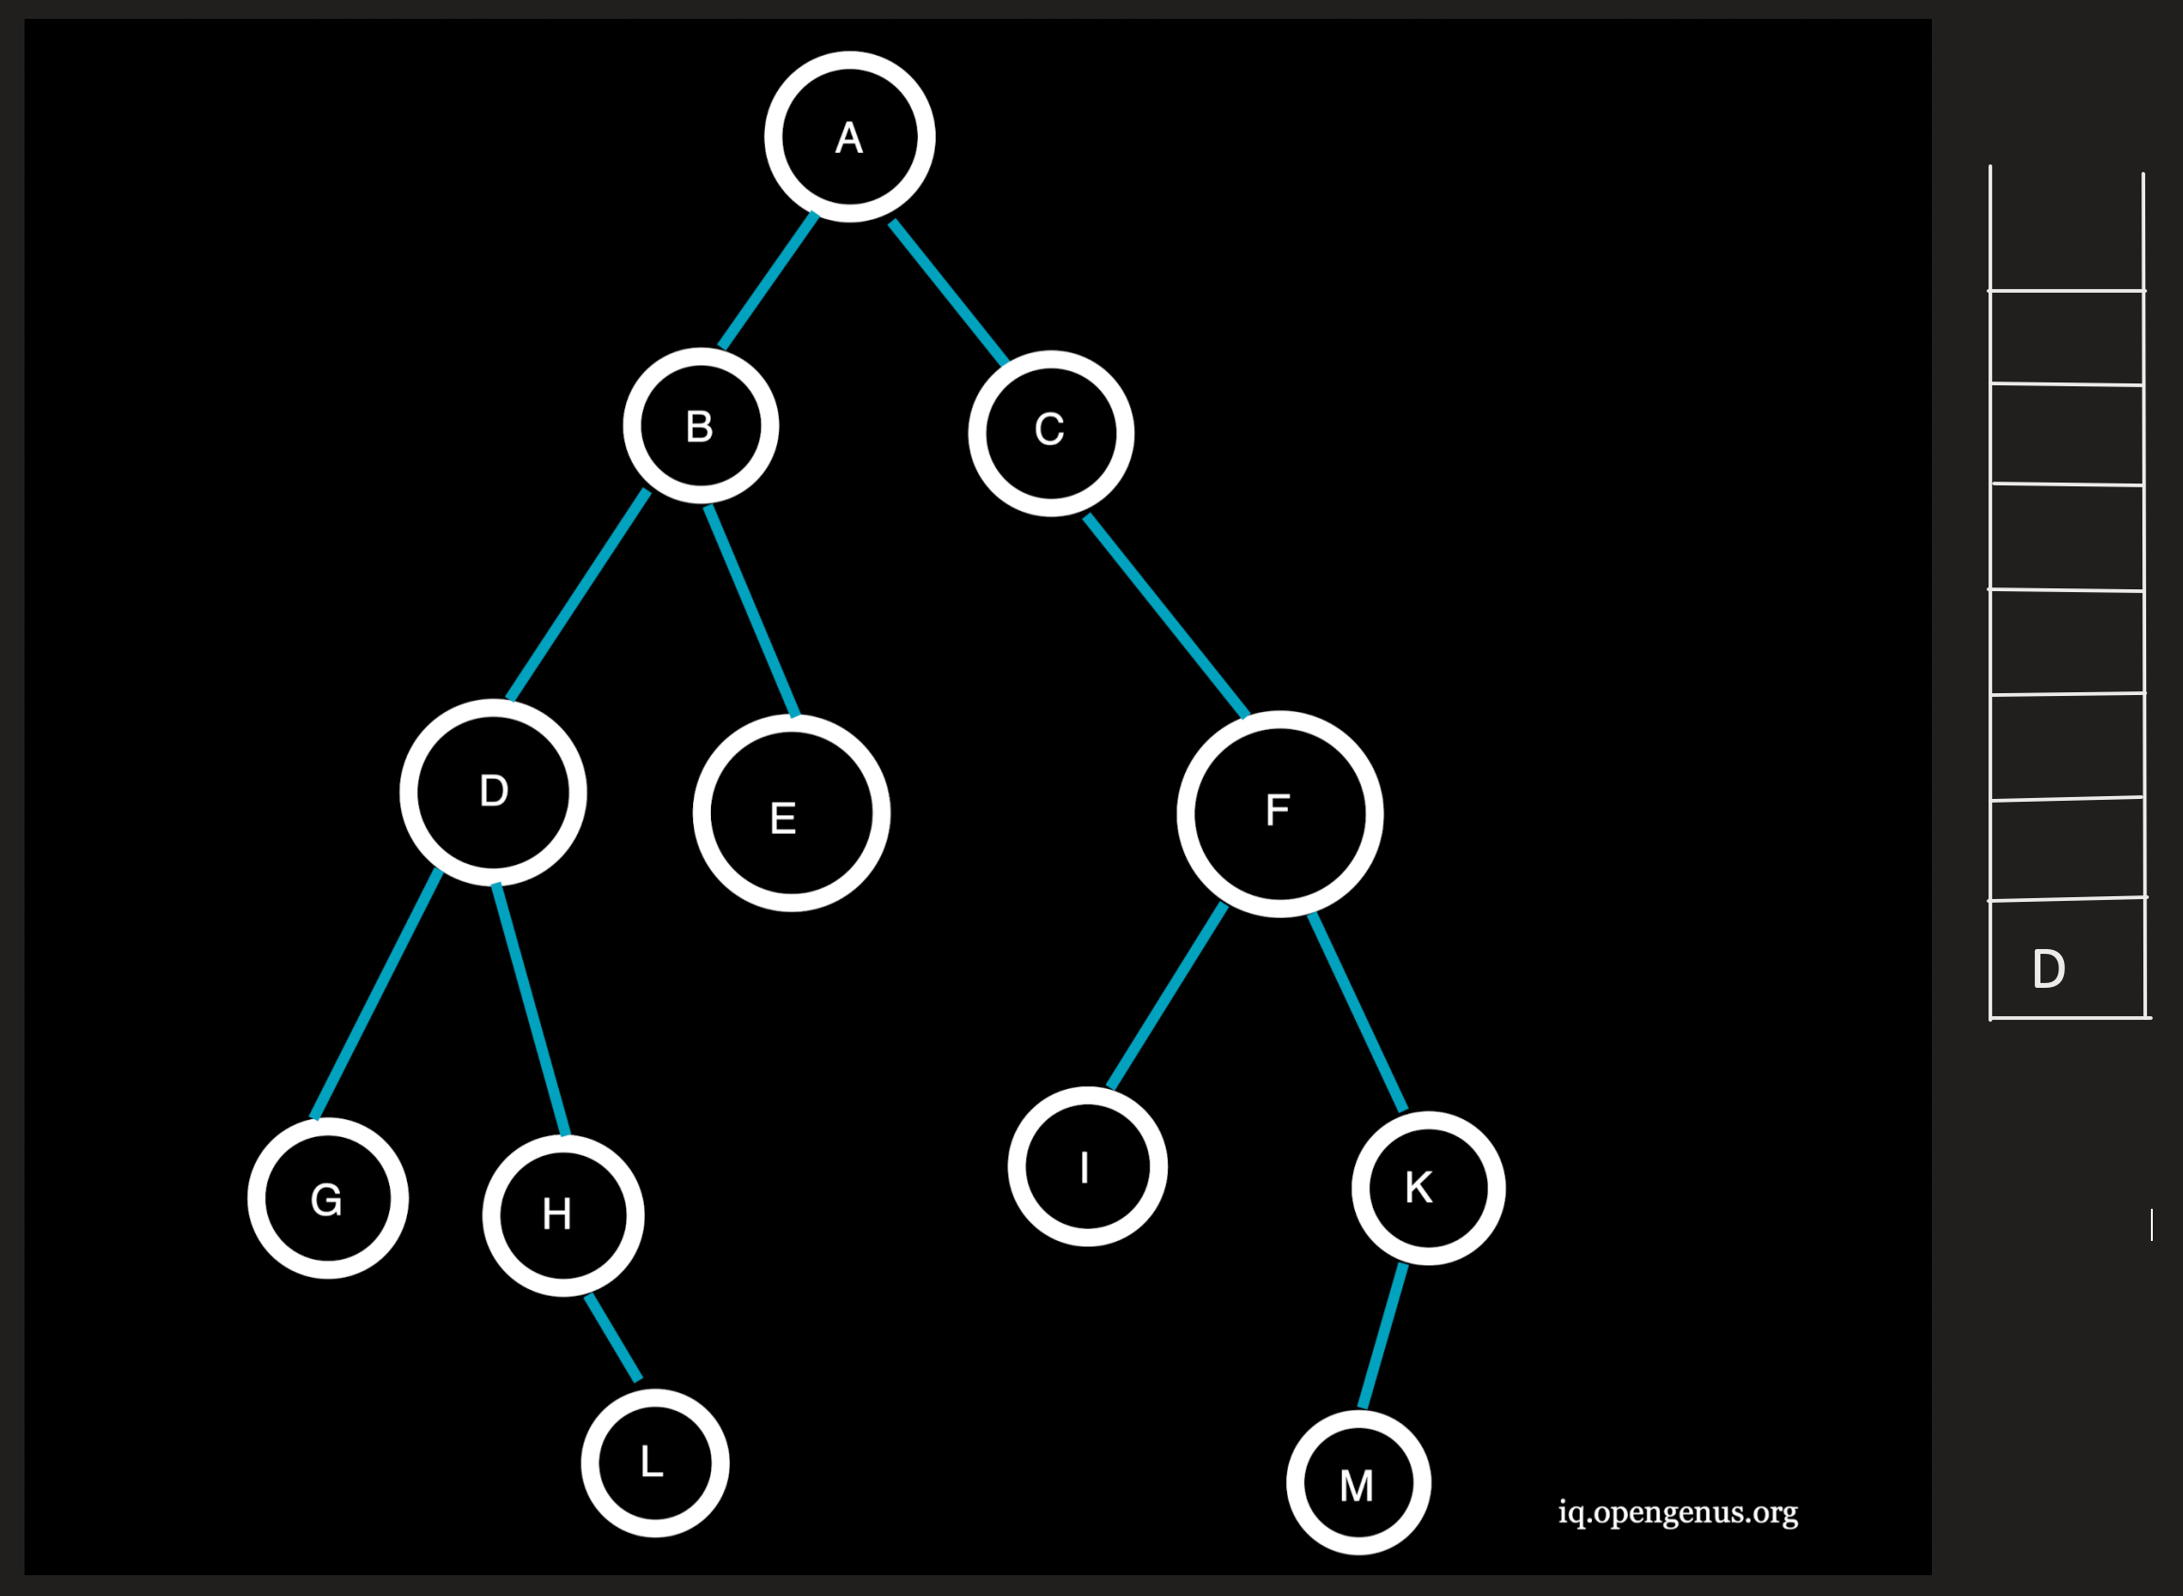

E being the topmost element is popped from the stack and since E has no neighboring nodes, no nodes are pushed onto the stack.  
Traversal: ACFBE

**Step 7 :**  
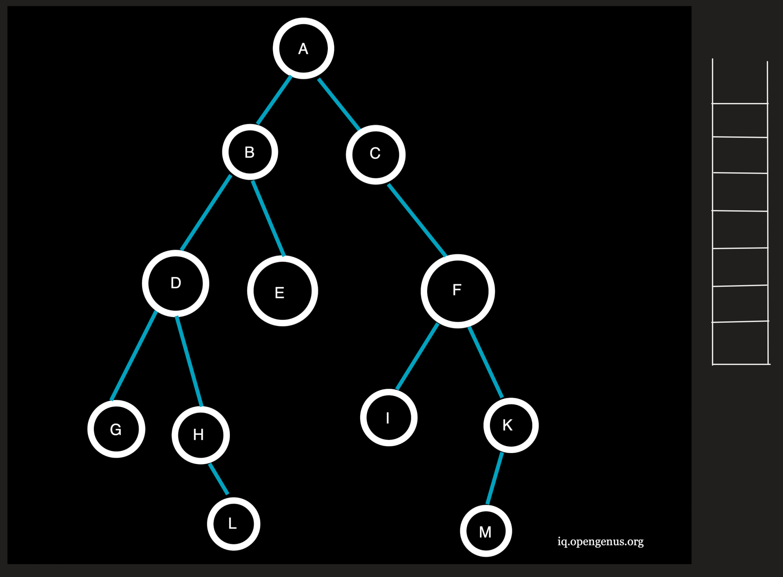

D being the topmost element is popped from the stack and the neighboring nodes G and H at depth=3(>l) will not be pushed onto the stack.  
Traversal: ACFBED

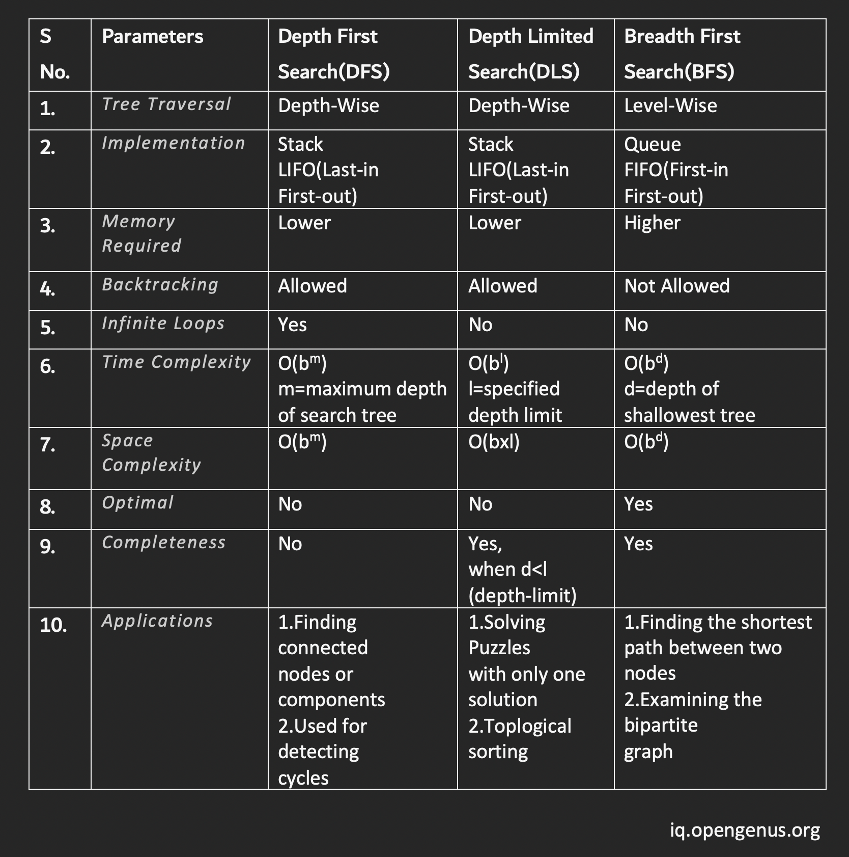

**ITERATIVE DEEPENING DEPTH FIRST SEARCH**

It is a combination of breadth first search and depth first search.

**ADVANTAGES**

Fast and less memory

Incorporates benefits of both BFS and DFS.

**DISADVANTAGES**

Repeats the work/process

